
Java Institute for Advanced Technology


Department of Examinations

COURSE(S) – (LEADING TO) | BSC (HONS) IN SOFTWARE ENGINEERING
UNIT NAME | HANDHELD DEVICE PROGRAMMING II
UNIT ID | JIAT/HHDPII
EXAMINATION ID | JIAT/HHDPII/EX01

MORAWAKAGE AKINDA METHMIKA PERERA
200421803135
COLOMBO

Project Name
EcoTrekk

Service Type
M-Commerce

Prepared for
EcoTrekk Adventures

Prepared by
Methmika Perera

Date
2026-02-19

Table of Contents
1. Document Purpose 4
2. Client Brief 5
3. Objective 6
4. Scope of Work 8
5. Administrative Panel 10
6. Standardizations 12
7. Delivery Schedule 14
8. Process Flow 16
9. Requirements from Client 19
10. Location of Work 21
11. Progress Reporting and Communication 22
12. Engagement Model 24
Appendix 01 – Sample UI Designs 28

Table of Figures
Figure 1: Project Development Process Flow 16
Figure 2: EcoTrekk Project Sequence Diagram 18

Document Purpose
The following document is addressed to EcoTrekk Adventures (Hereafter referred to Client). The copyright to this document is held by the Methmika Perera and nothing of the same shall be copied without the consultation of the same.
This is the official project proposal regarding the design and development of EcoTrekk, a mobile M-commerce solution devoted to renting outdoor camping equipment. It describes the business vision, technology scope, implementation plan and business structure that is needed to effectively carry out the solution.
This proposal is meant to define a common ground between the stakeholders on what the project intends to achieve, what will be the deliverables, and who will handle the execution of the project and how. It is also a strategic blueprint and operational agreement which directs the lifecycle of development of EcoTrekk.
This document ensures that all the parties in the proposal are on the same track in terms of project objectives, technical orientation, and delivery expectations. It is also supposed to act as a living reference document during the lifecycle of the EcoTrekk platform and assist with the informed decision-making, as well as efficient project governance.
In particular, this paper will focus on:
- Demonstrate an in-depth insight into the practical business issue EcoTrekk aims to resolve the problem of affordable and easy-to-acquire outdoor gear.
- State the technical and functional purposes of EcoTrekk M-commerce platform.
- Outline the development methodology, architecture approach, and implementation standards that would be used.
- Define the scope of the project, deliverables and limits of operation.
- Create communication, reporting and cooperation expectations.
- Present a well-organized project execution plan, quality control, and deployment.

Client Brief
The EcoTrekk is based on the business requirement of updating and digitalizing the outdoor equipment rental business by implementing a scalable mobile-first commerce platform. The vision of the client is to establish a convenient, technology-based ecosystem, in which the customers will be able to access high quality camping gear without the economic strain and logistical difficulties of owning the products. Today, the business of outdoor gear rental is quite fragmented, manual and relies on the physical interaction with the stores. This brings inefficiencies in inventory management, customer interaction and booking processes. EcoTrekk is suggested to be a centralized online platform that can simplify the process and improve the customer experience with the help of mobile technology. The client needs the solution that will satisfy the following major business and technical specifications:
- Requirement 1: Mobile Rental Marketplace.
Design an excellent Android-based M- commerce application that enables users to browse, choose, and book camping equipment using an easy mobile interface.
- Requirement 2: Real Time Inventory Synchronization.
Make sure that the availability of gears, prices, and the status of booking are updated in real time with a centralized back-end system to avoid any type of a double booking and enhance operational efficiency.
- Requirement 3: Offline Accessibility.
Offer a few offline capabilities which enable users to view recent catalog data where network connections are consistently unreliable.
- Requirement 4: Integrated Navigation and Communication.
Facilitate in-built mapping, directions and telephony functions so as to make pick-up organization and customer care simpler.
- Requirement 5: Automated Notifications and Engagement.
A system of sending booking confirmation messages, reminders, and promotions should also be implemented to enhance customer retention.
- Requirement 6: Administrative Control and Scalability.
Offer back-end administrative solutions to manage inventory, orders and customer data and make the place scalable as the business expands.
- Requirement 7: Improved Outdoor Usability.
Enhance the application by using mobile devices sensors and hardware integrations to make it work well in the real world outdoor.

Objective
The EcoTrekk project aims mainly at developing and deploying a commercial M-commerce mobile system to digitize and automate the outdoor camping gear rental business. EcoTrekk will be designed to be a scaled, safe, and customer-friendly ecosystem that allows linking customers to rental providers with an effective mobile experience. The project goals are organized into a number of strategic dimensions to guarantee the business impact as well as technical excellence.

3.1 Strategic Business Objective.
The main business goal is to make EcoTrekk a technology based rental market that enhances operational efficiency and market coverage. By transferring renting services to a mobile platform, the system will:
- Automate the manual booking and administration.
- Enhance the use of equipment and inventory turnover.
- Give more access to customers via mobile commerce.
- Increase brand awareness in outdoor recreation.
- Promote sustainable consumption by sharing gears.

3.2 Functional Objective
In terms of functionality, the goal is to have an all-inclusive feature set, which accommodates the entire rental lifecycle. The platform will enable:
- The ability to browse in real-time a dynamic gear catalog.
- Safe user registration and authentication.
- Cart management and rental bookings.
- Local caching online catalog access is available as well.
- In-built navigation to pick-up points.
- Confirmation and reminder notifications that are automated.
- Inventory and order control by administration.

3.3 User Experience Objective
EcoTrekk is focused on providing a quality mobile user experience that is optimized in outdoor conditions. Interfaces should develop with:
- User friendly and intuitive.
- Responsive to any type of device.
- Quick and dependable under real world application.
3.4 Technical Objective
The technical goal is to have a strong, sustainable architecture that will allow it to become scalable in the long term. This includes:
- Systematic client-server communication.
- Effective background processing and multitasking.
- Efficient offline data management.
- Extensible and modular code structure.
- Scalable backend server infrastructure.
Spring Boot and MySQL will be used for backend server and database to provide stability and performance.

3.5 Security and Reliability Objective.
One of the key goals is to secure user data and make systems reliable. The platform will implement:
- Confidential authentication and session control.
- Secured data transmission.
- Practical data storage safety measures at the local level.
- Effective error management and recovery system.

3.6 Growth and Innovation Objective.
In addition to the initial implementation, EcoTrekk is constructed with a perspective of future development. The long-term goal is to facilitate:
- High-end analytics and personalization.
- Mobile cross-platform support.
- Integration with new outdoor services.
- Outdoor safety features

Scope of Work
The EcoTrekk project scope of work involves the entire end-to-end development of a commercial mobile based M-commerce platform of outdoor camping gear rentals. The project will involve designing, implementation, integration, testing, and deployment of mobile and back-end elements needed to run a scalable rental ecosystem. This project will be developed on a native Android front with a solution of backend services that will be developed using Spring Boot and a relational database using MySQL. Some of the major deliverables and implementations that are covered by the scope of the project include the following:
Functional Requirements
The system will have all necessary functional capabilities necessary in a complete rental workflow and they will include:
- Mobile commerce friendly user interface design.
- Browsing of product catalogs and search.
- Rental booking and cart management processes.
- Interactive animation and event handling.
- Background multitasking of network and storage operations.
- Android advanced components like RecyclerView and fragments integration.
- Inventory and booking management tools.

Data and Connectivity
To guarantee reliability and performance, the EcoTrekk platform will adopt a hybrid data strategy, which will combine both the local and the remote storage systems. This includes:
- SQLite-based local data storage to support offline access to catalogs.
- Shared Preferences: session and application settings.
- Digital receipts can be saved in internal storage.
- Strong HTTP Communication with backend servers.
- Live synchronization of inventory and booking information.

Advanced Integrations
The application will use advanced mobile integrations to improve functionality and usability:
- Real-time alerts and reminders through a notification broadcasting system and receivers.
- Hardware integration such as telephony, multimedia playback and sensor control.
- Sensory based features like motion gestures and light-based UIs.
- Background services to enable effective multitasking.
Location Services
EcoTrekk will be using full-fledged location-based features that are Google Maps powered, including:
- Interactive store locator mapping.
- Pickup location through GPS-based navigation.
- Direction routing services
- Management of location permission.

Design and User Interface
The project will involve complete design and implementation of a modern, responsive mobile interface that meets commercial standards of usability. This includes:
- Professional UI/UX design
- Consistent visual styling
- Multiple device responsive layouts.
- Accessibility-oriented design factors.
Sample UI designs are attached in Appendix 01.

Non-Functional Requirements
The EcoTrekk platform will comply with a high level of non-functional performance requirements, which include:
- High level of reliability and system stability.
- Data security and authentication.
- Optimized performance and responsiveness.
- Future scalability.
- Maintainability via modular architecture.

Quality Assurance and Testing.
There will be a systematic testing procedure that will be used to test the performance and reliability of the system. This includes:
- Functional and integration testing.
- Stress and performance testing.
- Security validation
- User acceptance testing
- Bug tracking and resolution

Administrative Panel
The EcoTrekk platform will have a central Administrative Panel that will assist in the everyday business operations management of the rental business. This panel acts as the administrative command center and allows to effectively control inventory, users, and transactions without affecting the security of the system and the transparency of its work. The Administrative Panel takes care of EcoTrekk to have a professionally run commercial system and not just a simple mobile application. It offers the operating infrastructure needed to accommodate scalable rental solutions as well as long term business viability. Administrative Panel is deployed as a secured web-based interface that is linked to the EcoTrekk backend services which have been developed using Spring Boot. It would be able to grow with the business, and help with growth of operations in future. Administrative modules are organized in the following modules:
5.1 User Management
Administrators will have the ability to monitor customer accounts and platform integrity. This module includes:
- Registered users can be viewed and managed.
- Status control (activation/deactivation) of the account.
- Tracking user activity and rental history.
- Managing customer support requests.

5.2 Gear Catalog and Inventory Management.
With the inventory module, the administrators are in a position to keep an updated list of the rental equipment. Key capabilities include:
- Adding, editing, and deleting gear items.
- Posting of product images and multimedia content.
- Control of stocks and availability.
- Establish rental prices and promotional deals.

5.3 Order & Booking Management
This is the module that helps in the whole lifecycle in renting transactions. Administrators can:
- See incoming booking of rentals.
- Approve or modify orders
- Track pickup and return schedules.
- Update order statuses
- Produce transaction records and reports.
5.4 Reporting & Analytics
The Administrative Panel has a reporting dashboard which gives an insight on the business performance. Features include:
- Rental frequencies and revenue reports.
- Inventory utilization measures.
- User engagement statistics
- Decision-making trend analysis.

5.5 Security & Access Control
Role-based access management is used as a way to enforce security. This module includes:
- Authentications of administrators.
- Access levels that are based on permission.
- Activity logs and audit trails.
- Secure credential handling

5.6 System Configuration
Administrators are able to set global system settings which include:
- Notification templates
- Store location details
- Business hours and operations policy.
- Settings of system maintenance.

Standardizations
The EcoTrekk project will follow a detailed number of professional standards so that the end product satisfies industry standards of quality, security, performance and maintainability. These guidelines are used throughout the development lifecycle, including design and coding and testing and deployment. Through standardization practices, the project would be consistent, scalable and long-term viable of the platform by enforcing structured standardization practices.
6.1 Design Standards
The app will be developed according to principles of modern mobile design to provide a uniform user-friendly experience. The design choices will be made according to usability and practicality. The important design considerations are:
- Mobile-friendly responsive designs.
- User-friendly interface design.
- Well defined navigation hierarchy and patterns of interaction.
- Visual consistency among all the screens.

6.2 Coding Standards
The development will be based on the structured coding rules to ensure clean and maintainable software architecture. This includes:
- Reusable and modular structure of code.
- Regular naming conventions.
- Detailed inline documentation.
- Isolation of concerns with architectural designs.
- Best practices of version control.

6.3 Testing Standards
A strict testing framework will be used to promote reliability. Testing standards include:
- Unit testing of important parts.
- Module-to-module integration testing.
- User workflow functional testing.
- Post-update regression testing.
- Error reporting and debugging processes.

6.4 Security Standards
During development, security practices are incorporated in order to secure sensitive data. Standards include:
- Secure communication standards.
- Safe authentication management.
- Defense against typical mobile vulnerabilities.
- Safe storage of local data.
- Enforcement of access control and authorization.

6.5 Performance Standards
The platform will be streamlined to provide seamless performance on devices. Key goals include:
- Efficient resource and memory management.
- Quick response time and application startup.
- Background processing optimization.
- Scalable backend performance.

6.6 Documentation Standards
The project will be well documented to facilitate maintenance in future. This includes:
- Technical architecture documentation.
- API documentation.
- Setup and deployment guides.
- User operation manuals.

6.7 Compliance Standards
The project will pay attention to the applicable compliance and ethics standards, such as:
- Data privacy best practices.
- Accessibility considerations.
- Responsible data handling.

Delivery Schedule
The execution of the EcoTrekk project will be carried out following a systematic delivery plan that is going to provide regulated progress, transparency, and quality results. The plan is designed in well-established stages, each highlighting specific deliverables and checkpoints of reviews. This gradual process allows to constantly analyze and reduce the risk of development and to be consistent with the business goals.
Phase 1 - Requirement Gathering
The project starts with formal initiation stage, which involves the validation of business objectives and technical requirement completion.
- Activities include:
- Stakeholder alignment and project planning.
- Detailed requirement analysis.
- System architecture definition.
- Technical feasibility confirmation.
- Deliverable: Finalized technical specification and approved project roadmap.

Phase 2 - Design
At this stage, the visual and interaction structure of EcoTrekk is planned and checked.
- Activities include:
- Creation of wireframes and screen flow design.
- UI/UX prototype development
- Stakeholder design validation.
- Refinements through feedback.
- Deliverable: UI/UX approved designs that are all set to be developed.

Phase 3 - Development
This is the main implementation phase where all the functional modules are assembled and created.
- Activities include:
- Android application development.
- Database implementation and Backend API.
- Hardware and cloud functionality.
- First system integration and internal testing.
- Deliverable: Working beta of the EcoTrekk platform.

Phase 4 - Testing
The finished system is thoroughly tested in terms of stability and performance.
- Activities include:
- Integration testing and functional testing.
- Performance optimization
- Security validation
- Bug fixing and refinements
- Deliverable: Stable Release Candidate Version.

Phase 5 - Deployment and Client Review
The almost completed system is implemented under a controlled environment to be tested by the stakeholders.
- Activities include:
- Deployment configuration
- Client demonstration and review.
- Collection of feedback and final changes.
- Deliverable: Final build, which is approved by the client.

Phase 6 - Final Delivery and After Sales Support
The last stage is dedicated to the formal handover and the initial operational support.
- Activities include:
- Application builds and source code delivery.
- Documentation handover
- Deployment assistance
- Warranty support period commencement.
- Deliverable: EcoTrekk production-ready platform and project completion.

Process Flow
The development of the EcoTrekk project will be based on a systematic and step-by-step process that will be used to facilitate efficient implementation, quality production, and alignment with business goals. Process flow clarifies the logical order of activities that commence with initial requirement analysis until final deployment is completed with the activities that follow one another in logical order.
Figure 1: Project Development Process Flow
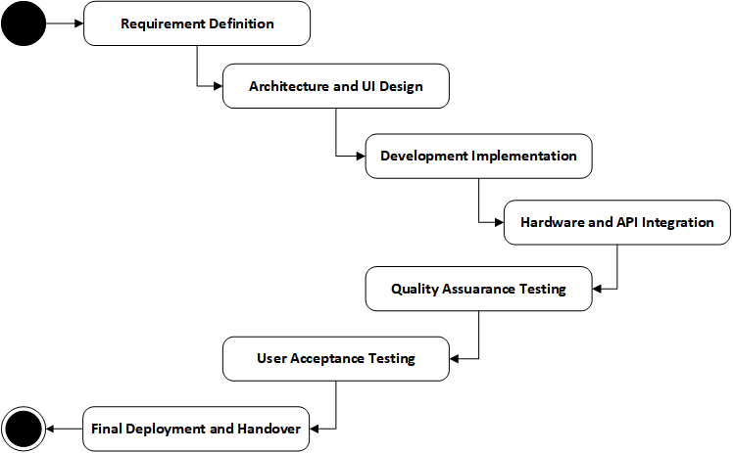

It is a workflow that involves disciplined engineering and combined with feedback to reduce risk and maximize the delivery, as much as possible.
Requirement Definition
This starts with the translation of business requirements into detailed technical specifications. This step lays a clear foundation towards development. During this stage:
- Analysis and documenting of project requirements.
- System workflows and user journeys are determined.
- Risks and technical feasibility are estimated.
- Success criteria and deliverables are validated.

Architecture & UI Design
When the requirements are decided, a system architecture and user interface are developed. This step produces the roadmap that acts as the guideline. Activities include:
- Developing the client-server architecture.
- Database structure planning.
- Defining API communication models.
- Designing UI wireframes and interaction flows.
Development Implementation
The development stage is used to develop the fundamental system parts. Activities include:
- Development of mobile frontends features.
- Implementation of backend services.
- Database configuration
- Hardware and multimedia integration.
- API connection and synchronisation.

Hardware & API Integration
At this phase, advanced integrations are added into the system. This includes:
- Sensor-based functionality
- Multimedia and telephony features.
- Mapping and location service.
- Cloud notification integration.

Quality Assurance
System reliability is achieved through a thorough testing process. Testing ensures a stable application and one that is ready to be used in production. Activities include:
- Integration testing and functional testing.
- Performance validation
- Security checks
- Bug Reporting and fixing.

User Acceptance Testing (UAT)
The stakeholders test the system in actual life situations to ensure that requirements have been met. Feedback is gathered and any final adjustments done prior to deployment.
Final Deployment
The final phase of the project is the formal deployment and hand over. Activities include:
- Application packaging and release.
- Documentation delivery
- Knowledge transfer and support arrangements.
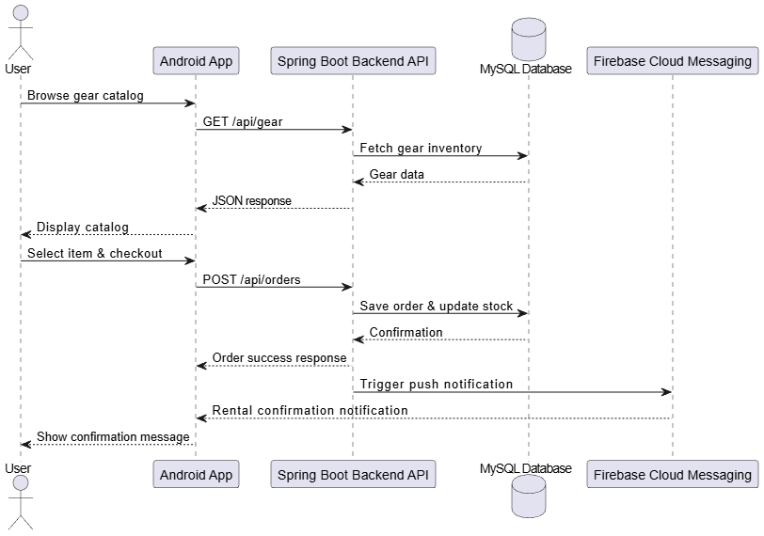
Figure 2: EcoTrekk Project Sequence Diagram

Requirements from Client
The effective implementation of the EcoTrekk platform requires the proactive cooperation and input of the client in time. The client will be required to offer the following information, resources, and operational support during the project lifecycle to guarantee effective development and alignment with business goals. These are important to ensure that delays are minimized, the uncertainty is minimized, and the proper implementation of business needs are achieved.

9.1 Business Information
The client should give proper and recent organizational information that needs to be used to set the platform, such as:
- Guidelines on official business name and branding.
- Physical pickup hub or physical store addresses.
- Contact phone numbers and communication channels.
- Operating hours and policies in business.

9.2 Product & Inventory Data
Proper catalog information is essential to the professional customer experience. In order to fill the EcoTrekk catalog, the client is required to provide:
- Descriptive product information.
- Rental pricing structures
- Inventory levels and availability policies.
- Exclusive product photos and media.

9.3 Technical Infrastructure Access
The client should facilitate the deployment of the back end by providing:
- Access to cloud server or hosting environment.
- SSL and domain configuration.
- Credentials of email or notification service
- Permission to integration services.

9.4 Feedback and Review Participation
During development stages, active interaction with clients is needed. The client is expected to:
- Take part in milestone review meetings.
- Give timely feedback of prototypes and builds.
- Approve deliverables within agreed timelines.
- Include change requests in an understandable manner.

9.5 Operational Policies
Client should specify business rules that affect the behavior of the system, including:
- Rental terms and conditions
- Refund and cancellation policy.
- Late returns processes.
- Customer support workflows

Location of Work
The EcoTrekk project shall be designed under a hybrid working model which consists of remote development with controlled local testing environments. This method allows being flexible, dedicated to performance, and involves the efficient use of resources without compromising professional development levels.
The major development processes of the project, such as coding, system design, and documentation, will be carried out remotely through secure development tools and version-controlled repositories. Meanwhile, the app will be tested in local conditions with both physical Android devices and emulators to check the performance in the real world and compatibility. To ensure data integrity and traceability, all the project assets such as source codes and documentation will be stored in a centralized repository.
The hybrid model supports:
- Special purpose independent development with low overhead.
- Secure cloud-source code management.
- In-house local testing and debugging.
- Rapid iteration and flexible scheduling.
- Effective backend and mobile integration.

Progress Reporting and Communication
The effective implementation of the EcoTrekk project is based on clear and regular communication. We shall have a structured reporting system that would bring transparency, accountability and timely decision making across the development lifecycle. The communication plan is aimed to ensure that the stakeholders are aware of the progress, risks as well as the impending milestones and to solve problems within a short time.

11.1 Weekly Progress Reports
Each week a formal progress report will be presented. These reports give objective insights on project momentum. Reports will summarize:
- Finished development activities.
- Current milestone status
- Risks or blockers identified.
- Activities planned to be done in the next week.

11.2 Regular Review Meetings
There will be scheduled reviewing sessions where project status will be discussed and deliverables will be validated. The frequency of meeting can differ according to a project phase. These meetings will:
- Show new features that have been completed.
- Get feedback on stakeholders.
- Ensure that goals are in line with objectives.
- Resolve technical or operation issues.

11.3 Daily Operational Communication
The communication pathways like email or collaborative messaging platforms will be employed on a day-to-day basis to coordinate:
- Quick clarifications
- Issue reporting
- Minor updates
- Scheduling adjustments

11.4 Milestone Presentations
Formal milestone presentations will be done at the end of every major project phase (design, development, testing) to:
- Showcase deliverables
- Get the approval of stakeholders.
- Check readiness to continue.

11.5 Documentation and Knowledge Sharing
All key decisions, architectural updates, and implementation notes will be recorded and communicated to the stakeholders. This will build an open body of knowledge and will help in future maintenance.

Engagement Model
The EcoTrekk project engagement model outlines the professional structure under which collaboration, ownership, responsibilities, and operational expectations would be applied between the stakeholders and the developer. Since EcoTrekk is a full stack M-commerce site that requires mobile development, backend services, cloud integration, and hardware interaction, this engagement model focuses on accountability, transparency, and sustainability over the long run.
The model is designed in such a way that it encourages effective individual growth and at the same time makes the system provided commercially feasible, maintainable and scalable to accommodate future growth.

12.1 Intellectual Property (IP)
Any intellectual property created under the EcoTrekk platform shall be considered proprietary project deliverables. This includes:
- Android mobile application source code.
- Database schema and API Backend.
- UI/UX designs and visual materials.
- System architecture and technical documentation.
- Build scripts and deployment configurations.
After the project is completed successfully and all the agreed obligations have been fulfilled, the entire ownership of the system will be handed over to the client.
This project will use third party frameworks and SDKs (networking libraries, UI frameworks, cloud SDKs, etc.) with the exception that they fall under their respective licensing. Any such components shall be recorded so as to comply with the law and be transparent.

12.2 Software Ownership and Source Code Delivery
Upon the final project handover, the client will be provided with full administrative access to all project software resources, such as:
- Full Android and back-end source code.
- Database schema and configuration files.
- API documentation
- Instructions on deployment and set up.
- Version history and repository structure.
The delivery will be done through a secure repository transfer or an encrypted archive package. The delivered materials will be structured and recorded to facilitate easy integration of future development teams.

12.3 Development Methodology
EcoTrekk is going to be built in an agile-based, milestone-oriented approach that is streamlined to maximize the efficiency of solo development. All milestones will be aimed at functional modules, including catalog browsing, workflow booking, hardware integration, and cloud services. This will enable problems to be spotted early and gradual corrections made toward a production-ready platform. The methodology emphasizes:
- Iterative feature releases
- On-going integration and testing.
- Incorporation of rapid feedback.
- Incremental system validation.

12.4 Quality Assurance and Acceptance Criteria
The process of quality assurance is incorporated throughout the project lifecycle development. Every major deliverable will be defined to have acceptance criteria. The feature is said to be complete when it meets agreed functional performance criteria. Every milestone will be validated in a structured manner that will involve:
- Physical or functional testing of the application features.
- API integration testing.
- The stability and performance tests.
- Android device compatibility test.

12.5 Warranty and After-Sales Service
The warranty is concerned with the operational reliability of delivered platform. A 12 Month warranty time will start as soon as final deployment is finished. During this period:
- Performance defects that are critical to core functionality will be addressed.
- The problems with stability and performance will be resolved.
- Minor usability enhancements can be done.
Further maintenance, addition of features or scaling of the system outside the warranty will be provided under a different support agreement.

12.6 Scope Governance & Change Management
The accepted scope of the project outlines the delivery limits of EcoTrekk system. Any changes or additions that are not a part of the agreed requirements will be handled through a formal change management process. This process includes:
- Resource and time impact assessment.
- Record keeping of ordered changes.
- Pre-implementation approval.

12.7 Roles and Responsibilities
EcoTrekk delivery involves responsibilities that should be clearly defined.
Developer Responsibilities:
- System design and implementation.
- Code quality and documentation.
- Testing and deployment
- Progress reporting and milestone delivery.

Client/Stakeholder Responsibilities:
- Timely approvals and feedback.
- Requirement clarifications
- Availability of resources needed.
- Involvement in review meetings.

12.8 Communication and Collaboration Framework
Communication will be based on a reporting model that helps in enhancing transparency and accountability. Every discussion and decision will be recorded to ensure consistency during the project lifecycle. This includes:
- Planned milestone reviews and Weekly progress summaries.
- Showcases of functionality.
- Sharing of centralized documentation.

12.9 Payments and Commercial Structures
Payments will be made based on the completion of milestones to reward incentives based on quantifiable progress in the following way:
- 30% - Initial project start-up payment.
- 50% - Installment payments on a milestone basis.
- 20% - Payment by acceptance of final delivery.
Formalized commercial terms would be established in a different contract.

12.10 Confidentiality and Data Protection
System architecture, business logic, user data structures and all project related information will be considered as confidential. The two parties are willing to ensure confidentiality of sensitive information and only allow access to the authorized individuals. Practices of secure development will be adhered to in order to protect project assets.

12.11 General Conditions
EcoTrekk system will be built under the condition of the modern software engineering standards and the industry best practices. The system will prioritize:
- Scalability and maintainability.
- Security and performance
- Clean architecture and documentation.
- Stable and reliable technologies used.

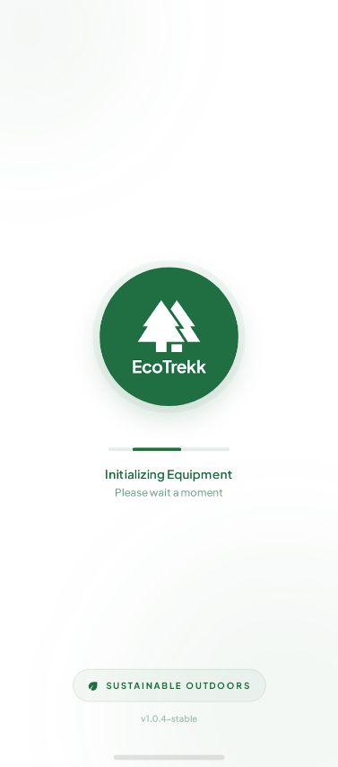
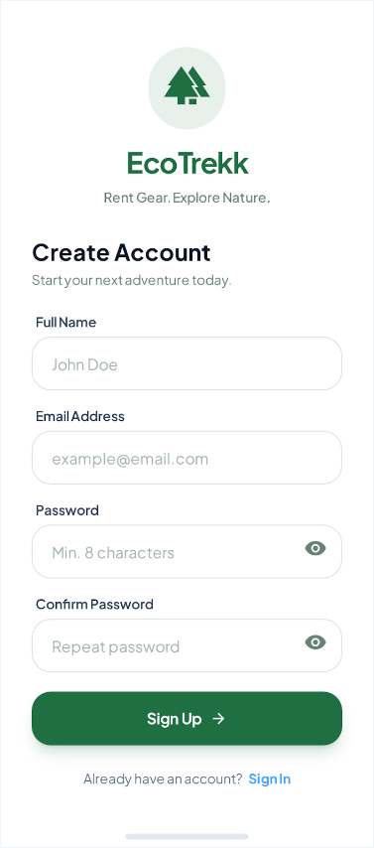
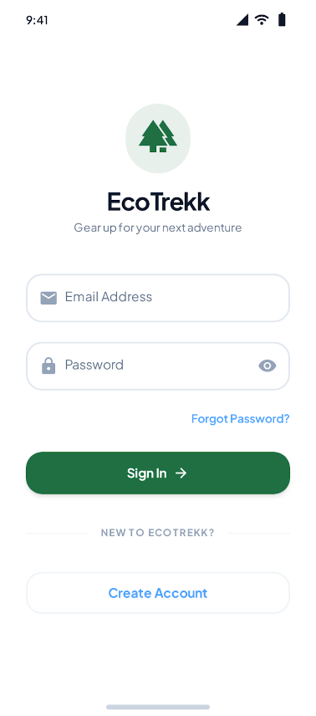
Appendix 01 – Sample UI Designs
Figure 3: Splash Screen
Figure 4: Registration Screen
Figure 5: Login Screen
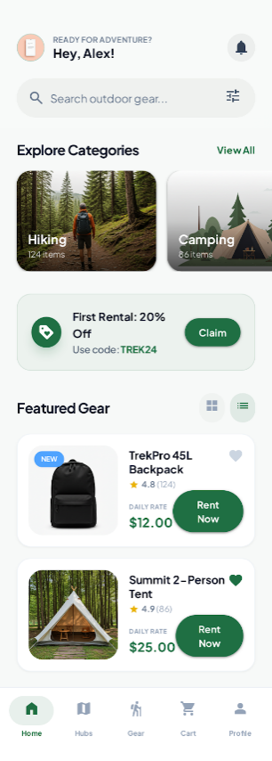
Figure 6: Home Screen
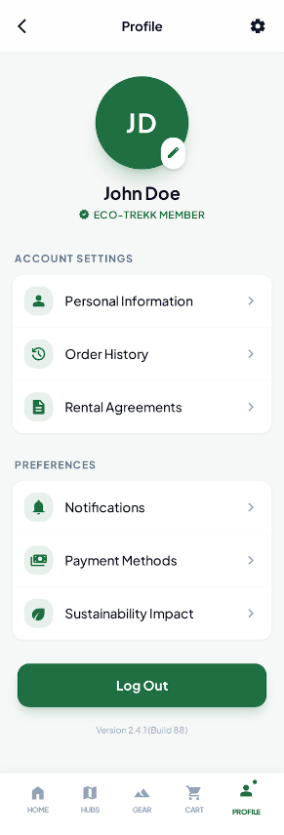
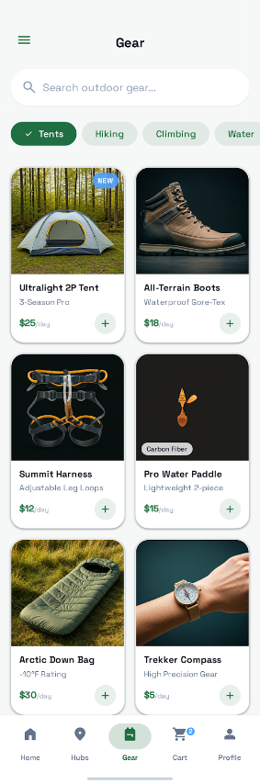
Figure 8: Profile Screen
Figure 7: Gears Screen

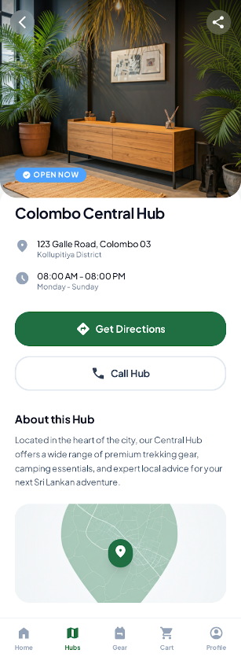
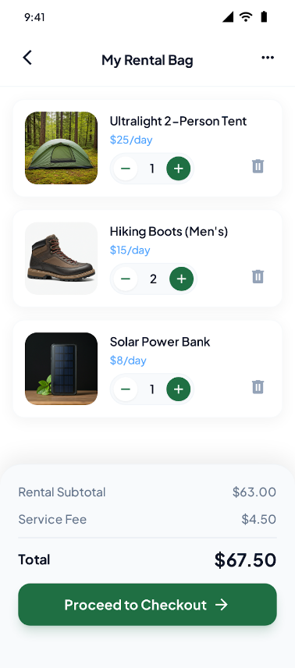
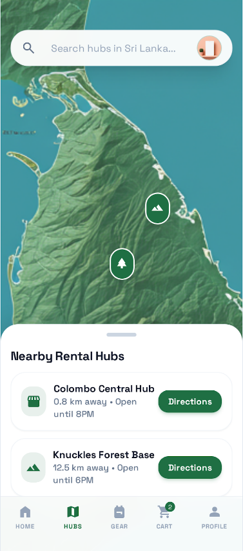
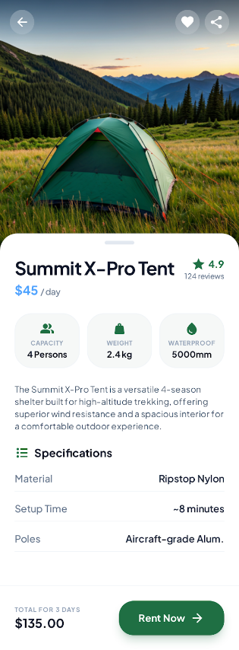
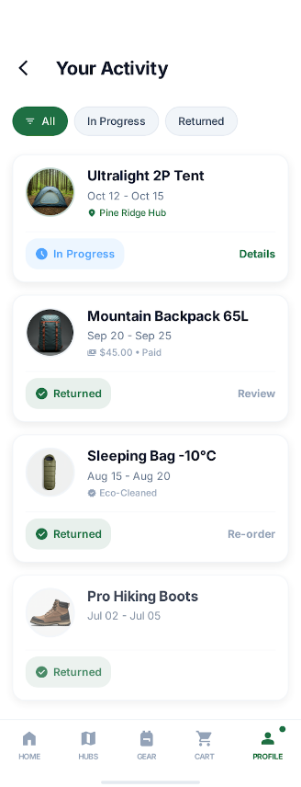
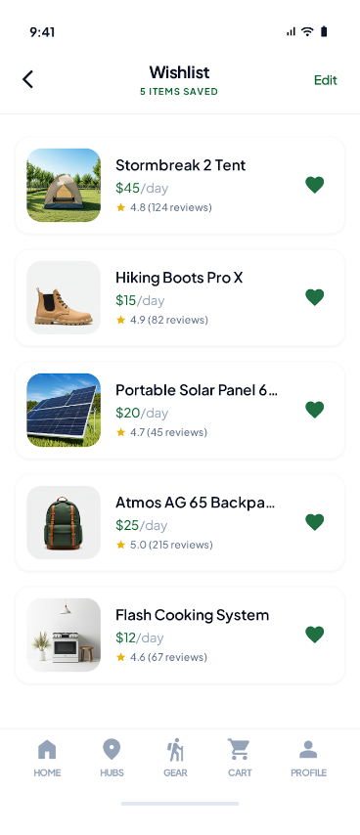
Figure 10: Hub Details Screen
Figure 9: Hubs Screen
Figure 11: Cart Screen
Figure 14: Activity History Screen
Figure 13: Product Details Screen
Figure 12: Wishlist Screen

